August 2017

South Warwickshire GP practices raise hundreds of pounds for local hospices
More than £900 has been donated to local hospices this week, thanks to GP practices across South Warwickshire.
The South Warwickshire GP Federation (SWGP) presented cheques of £450 each to the Shakespeare Hospice in Stratford-upon-Avon and the Myton Hospice in Warwick. The money was raised by donations from staff at the recent Primary Care Awards event, which recognises the achievements and dedication of practice teams across the area.
Over 200 staff from GP practices in the federation gathered at the awards dinner at the Hilton Hotel, Warwick, in June, which was sponsored by a number of local and national organisations. Staff were nominated in eight categories, from Nursing Team Achievement to the Extra Mile award. The winners were:
- Excellence in Medical Training Award: Castle Medical Centre, Kenilworth
- Excellence in Prescribing Award for Quality & Safety: Suzanne Stanley, Shipston Medical Centre
- End of Life Care Award: Sam Day, Clarendon Lodge, Leamington Spa
- Public Health – Best Work in Healthy Lifestyle Award: Castle Medical Centre, Kenilworth
- Best Modernisation Award: Ben Evans, Kineton
- Nursing Team Achievement Award: Rother House Medical Centre, Stratford-upon-Avon
- Administration Team Achievement Award: Alice Partridge & Wioleta Zak, Bridge House Medical Centre, Stratford-upon-Avon
- Extra Mile Award: Dr C Bates & Dr G Rowland, Lapworth Surgery, Solihull
Jon Moll, Director at SWGP said: “We set up the awards two years ago as we felt it was important to recognise the hard work of primary care staff in the area. Often faced with significant challenges, our staff are constantly striving to deliver the highest possible standard of care for patients and these awards give us an opportunity to thank them and to celebrate their achievements.
“We are delighted to have raised so much money on the evening for these two worthy causes. Both hospices play a vital role in supporting general practice and do an amazing job caring for people at a time of need.”

The cheques were presented and sent to Myton Hospice and Shakespeare Hospice by Jon Moll, Director at SWGP.

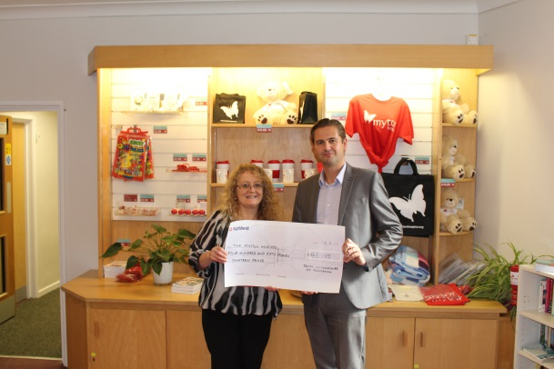
For more information visit www.southwarwickshiregps.nhs.uk/primary-care-awards

Notes to editors
For media enquiries please contact: Katie Tysome or Catherine Martin on 01608 495955
About SWGP
The South Warwickshire GP Federation is made up of 34 GP practices across South Warwickshire, located from areas including Warwick, Leamington, Alcester, Shipston and Southam. The federation has been established to deliver enhanced services to benefit the 278,000 patients they cover, and improve working practices for staff.

